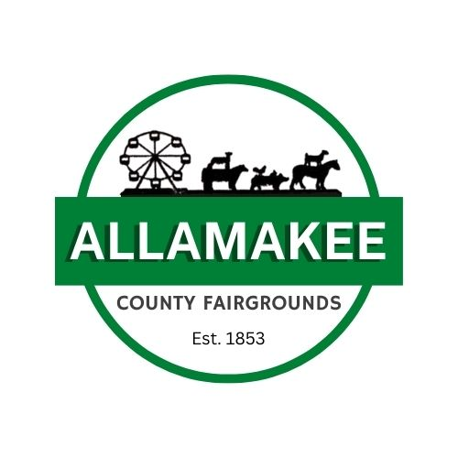
Little Miss Allamakee County Fair Contest

Rules/Regulations and Dates

The rules for this competition include:

- She must reside in Allamakee County.
- She must 7-9 Years of age by July 16, 2024 and plans to participate in the Allamakee County Fair in some way. For example:
o Clover Kids, Kidde Tractor Pull, Kidde Calf Show, Mutton Bustin’
- She must complete and mail or email the application to the below address, no later than June 15, 2024 (Applications must be mailed to below address to be accepted).
Diana Davison
Attn: Little Mr. and Miss Committee
516 2nd St NW
Waukon, IA 52214
- She must be present for judging at the Allamakee Pavilion on Wednesday, July 17, 2024 at 3:00 p.m.
- If she is crowned she must be present for the pie auction Wednesday, July 17, 2024 at the Tractor Pull, before intermission
o Contestants are asked to dress in formal attire. We will take a group photo prior to the crowning
§ We will take a photo of the newly crowned royalty after the crowning

Little Miss Allamakee County Fair Contest
Little Miss Expectations

- Represent the fair with a smile.
- Be at Grandstand events to assist Allamakee County Fair Queen/Princess when possible.
- Welcome people to the fair.
- Be visible, be seen.
- Attend Livestock shows to assist Allamakee County Fair Queen/Princess when possible.
- Participate/Be present at Kids Day (Friday of fair).
- Attend livestock auction (Monday of fair).
- See list of 2024 Fair Events, attend most events when possible.
o Littles must have a chaperone (parent, guardian, older sibling, etc.) with them at the event(s) they choose to attend.
- Attend the 2024 Pie Auction of the fair (Wednesday & Saturday of fair).
- 2024 Little Miss will need to be present at the 2024 Allamakee County Fair Coronation.
- Will need to try and attend parades and events throughout the year as Little Miss.
We will communicate details regarding parades as they arise.
Parades include but are not limited to:
- Corn Days, Waukon
- Fish Days, Lansing
- Dairy Days
- St. Patricks Day, Waukon
- Memorial Day, Harpers Ferry
- Memorial Day, Waukon
- Homecoming
- Big 4 Fair, Postville
Little Miss Allamakee County Fair Application
POSTMARKED BY: June 15, 2024

Applying For: ____ Little Mr. ____ Little Miss

Candidate’s Name: ____________________________________________________________________
Address: ____________________________________________________________________________
School/Grade Completed: _________________________________________ Age: ________________ Parents/Guardians Names: _____________________________________________________________
Parents/Guardians Cell Phone and Email: ________________________________________________
What is your favorite thing about The Allamakee County Fair and why?
_____________________________________________________________________________________ _____________________________________________________________________________________
What makes you a good friend?
_____________________________________________________________________________________ _____________________________________________________________________________________
What do you want to be when you grow up?
_____________________________________________________________________________________
If you could show or make one thing for the fair, what would it be?
_____________________________________________________________________________________
By signing this document, I hereby agree to rules and requirements of the Little Miss Allamakee County Fair Contest and furthermore, grant the Allamakee County Fair the right to take photographs of me and my family and grant that they may use such photographs of me for any lawful purpose including but not limited to publicity, illustration, advertising, and web content.

Candidates Signature__________________________________________ Date ____________
Parent/Guardian Signature ____________________________________ Date ____________ Please Email a digital headshot photo of candidate to allamakeefairqueen@gmail.com

